PROJECT DELIVERABLE 3: DATABASE AND DATA WAREHOUSING DESIGN

Student Name
Professor Name
Due Date

Introduction
Nearly every company has huge data that it should manage to enhance its productivity. Having this big data collection which needs to be properly managed, administrators are bound to designing a warehouse in fear of data loss. Talking of a complete data management system, a warehouse is a collection of databases that are used on a daily basis by the company. When the company website is visited, for instance, thousands of records are gathered which ought to be saved since they will at some point be needed for analysis. The analysis gives the company a go ahead of success depending on how the data was collected and stored. To enhance the company analytic operations, I (CIO) will hire a warehouse data management expert.
Justification for Data Warehousing
With the growth of data that companies, institutions, and other organizations have to manage, a new technology has been developed that tries to simplify the hectic analog data management – and this is the Data Warehousing system. This technology entails the storage of Big Data for organizations in a systemic manner for easy retrieval during analysis. In a warehouse, data is structured and organized well bring out its resourcefulness. Although a warehouse is somehow similar to a database, it is more closely designed for query and analysis processing as opposed to a database which entails transactional processing. One of the absolute advantages of a warehouse over a database is that a warehouse makes it possible for data recording, other modes of collection, and sieving it to fit different systems at higher levels. It is worth noting that this data will have historical data that is obtained from transactional data. This is very important as it will assist the company in the consolidation of data from different sources by distinguishing transactional and analysis workloads.
ETL and OLAP features are also present in a data warehouse system. ETL simply means Extraction, Transportation, and Loading while OLAP is an abbreviation for Online Analytical Processing Engine. These are features that scrutinize the processes of data gathering, collection, and finally availing it to tits users for business reasons. Data in a warehouse system is stored in a reliable manner, secure enough, and usually easy to analyze, process and manage. As businesses grow, the need for a data warehouse arises since big data is being managed.
Specifically, a Data Warehouse is desired for the following:
Data integration
In most cases, enterprise data is used in an organization. This is the data that is large, and detailed, and is distributed to different external systems that have proximal relations with the business at hand. In a company, it is also vital to analyze data across the different systems by channel, location, and time. Data integration brings all these data under one management (Herschel & Jones, 2005). This saves time and other lengthy protocols that are faced during analysis and processing. A data warehouse aids in the analysis and processing by generating reports, sorting and merging data. This technology is, therefore, serves multipurpose objectives – reliable storage and excellent integration of data. A data warehouse contains data that is fully integrated, volatile free, time variant, and subject oriented. A warehouse helps management view the business in an exposed 360 degrees view.
Reporting and Analytics advancement
As mentioned, a data warehouse supports query and reporting analysis. Practically, this means that the model is customizable to the exact subject areas of concern. This is an easier way that fastens the processes of analysis since queries are easily framed as opposed to the many data structures and lengthy tables of a database (Ariyachandra & Watson, 2006). This means that with a warehouse data model, retrieving a complex information is done in a simple few steps. Besides that, one is also able to perform a fast analysis which is multidimensional. A Data Warehouse model readily supports querying, reporting, and task analysis. This technology also helps perform a multi-level trend analysis. This entails the analysis of the most vital trends at entry level across different dimensions like time, location, product, and their hierarchies. The model makes reporting, data analysis, and visualization pretty simple.
Knowledge Discovery and Data Mining
Data mining and the discovery of knowledge are processes of an automated extraction hidden confidential information that is derived from big data. A good example is the classification models that are used purposely to classify data into low, medium, and high statistics. This is different from the classification into one statistic that fits all features (Tayi & Ballou, 1998). These Knowledge Discovery and Data Mining features use different statistical and mining techniques that are determined by subject, possible data cleansing availed by well-designed and structured Data Warehouse Model.
Executive Information System
This model and technology also makes it possible for a business to use Executive information. This is simply a way that enables the company executives to have a clear picture of the organization in terms of performance and hence make concrete decisions. Executives want key performance indicators delivered to them. What is stressful and tedious in this delivery is the cross department and cross product analysis which are basic when manually done. With a warehouse data management system, these functionalities are already structured in support of the said analysis. This saves on time and resources (Ariyachandra & Watson, 2006).
Performance
Database performance is very vital for all companies that generate big data. A data warehouse model has a structure that is optimizable to perform complex querying and process analysis. A database provides a transactional system which makes it hard to form ad hoc queries. With a Data Warehouse system, this is made much easier saving on time and resources. The storage of historical information for a long period tampers with the performance of a system which does not in any way affect a Data Warehouse (Ariyachandra & Watson, 2006). This is why Data Warehouse is always preferred.
Practices to follow to build a Data Warehouse
- Use a hybrid data model approach for better optimization which allows fast information retrieval.
- Careful design of data acquisition and cleansing process for the data warehouse. This ensures that process will be accurate. The Extraction, Transportation and Loading solution is an every time event since records are updated every now and then.
- Designing metadata should be subject to sharing among the different components of a Data Warehouse system.
- Data quality is a key consideration to enhance accuracy and meaningfulness (Tayi & Ballou, 1998).
- Communication and training form vital features for the system. Training allows data is based on quality attributes, reporting success, privacy and confidentiality and data collection as well as access.
- Data store should be put in place for easy retrieval.
Data schema
Schema defines the structure of a table.
- Page
- Visit table
- Client
- Registered user
- Payment
- Status code
- Time period
Main tables of the database schema
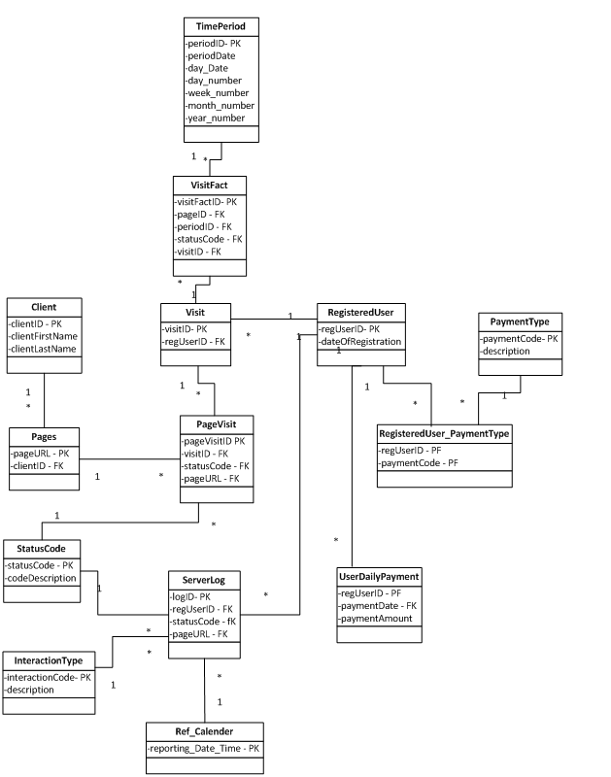
ER Diagram
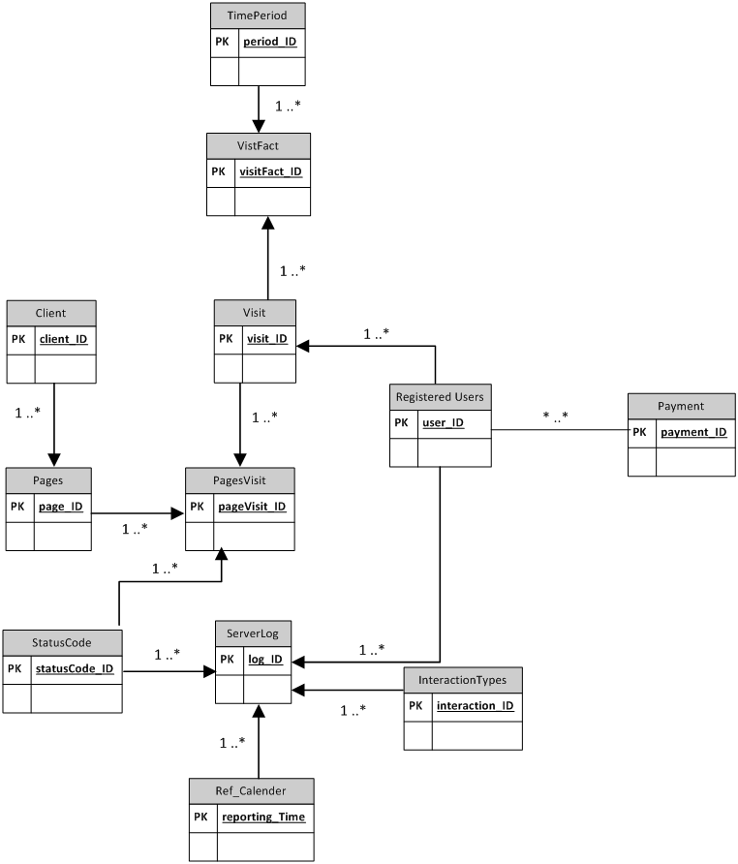
Data flow
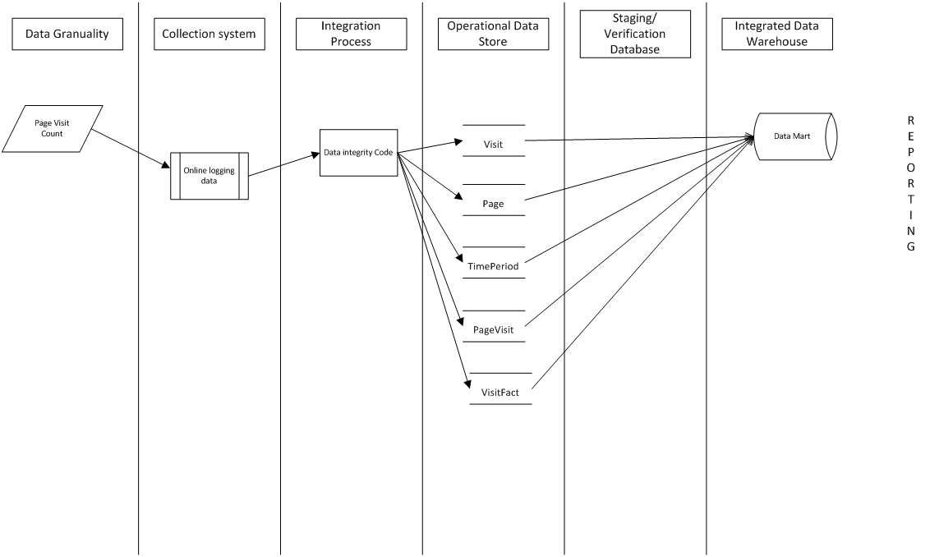
Input and output mapping
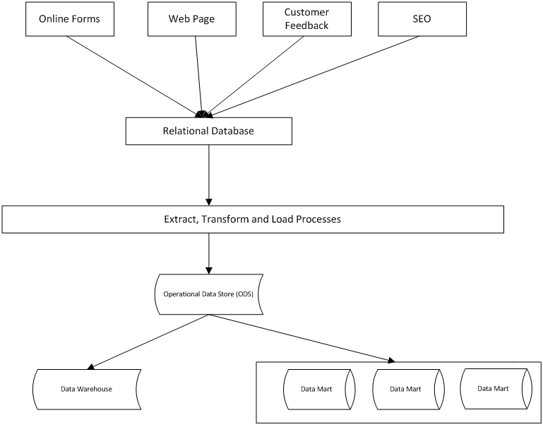

References
- Ariyachandra, T., & Watson, H. J. (2006). Which data warehouse architecture is most successful?. Business Intelligence Journal, 11(1), 4.
- Herschel, R. T., & Jones, N. E. (2005). Knowledge management and business intelligence: the importance of integration. Journal of knowledge management, 9(4), 45-55.
- Tayi, G. K., & Ballou, D. P. (1998). Examining data quality. Communications of the ACM, 41(2), 54-57.

